**Press Release** **31st October, 2023**

**PIAC ELECTS EMERITA PROFESSOR ELIZABETH ARDAYFIO- SCHANDORF AS FIRST FEMALE CHAIRPERSON**

Members of the Public Interest and Accountability Committee (PIAC), the oversight body with responsibility for the prudent management and use of petroleum revenues, have elected Emerita Professor Elizabeth Ardayfio-Schandorf, representative of the Ghana Academy of Arts and Sciences (GAAS) as its new Chairperson.

She was unanimously elected as Chairperson by the Members of the Accountability Committee at a meeting on Tuesday, 25th October, 2023. She takes over from Professor Kwame Adom-Frimpong.

Emerita Professor Ardayfio-Schandorf is the first woman to be elected as Chairperson since the inception of PIAC and will serve a one-year term.

Accepting her election, Emerita Professor Ardayfio-Schandorf expressed gratitude to the Members of the Committee for the confidence reposed in her. She urged Members to collaborate and work as a team to help fulfil the mandate of PIAC, which is to ensure the efficient and prudent management and use of petroleum revenues.

She also used the occasion to pay glowing tribute to the immediate past Members of the Committee for their role in fulfilling the mandate of PIAC.

Emerita Professor Elizabeth Ardayfio-Schandorf has a distinguished academic career and is a trail blazer in many fields. Her interests and engagements started in the early 1970s and have been nurtured over five decades through teaching, research, mentoring, consulting services and community outreach programmes.

She is a Geographer, an Environmental Advisor and Expert in Rural Energy Systems and a Development Consultant. She also has passion for Family and Gender Research/Analysis, Women’s Empowerment and Advocacy.

At the same meeting, the Omanhene of the Breman Asikuma Traditional Area in the Central Region, Odeefuo Amoakwa Buadu VIII, who represents the National House of Chiefs was elected Vice Chairperson to serve a one-year term. He is also the President of the Central Regional House of Chiefs.

Odeefuo Amoakwa Buadu, enstooled Paramount chief in 2009, is a past student of St. Augustine’s College in Cape Coast and Kwame Nkrumah University of Science and Technology (KNUST) in Kumasi where he obtained a degree in Mechanical Engineering. He holds an Executive MBA from the University of Ghana Business School and a Diploma in Chieftaincy from the Otumfuo Centre for Traditional Leadership at the University of Professional Studies Accra (UPSA).

Odeefuo has a strong engineering and business management experience, and also has the ability to build shared vision and lead teams of professionals to new levels of success in a highly competitive environment. He has over 11 years of chieftaincy experience with proven delivery of unity, peace and progress in his traditional area.

-ENDS-

***About PIAC***

*The Public Interest and Accountability Committee (PIAC) was established under Section 51 of the Petroleum Revenue Management Act (PRMA), 2011 to among others, monitor and evaluate compliance with the Act. The Committee was inaugurated and commenced work on 15th September, 2011*.

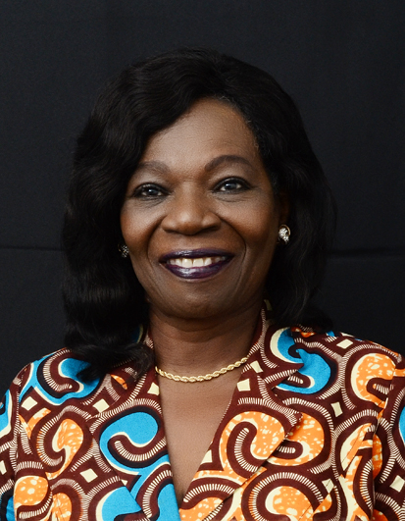

*Emerita Professor Elizabeth Ardayfio-Schandorf – First Female Chairperson of PIAC*